Trustee Recruitment

Candidate Information Pack

February 2023

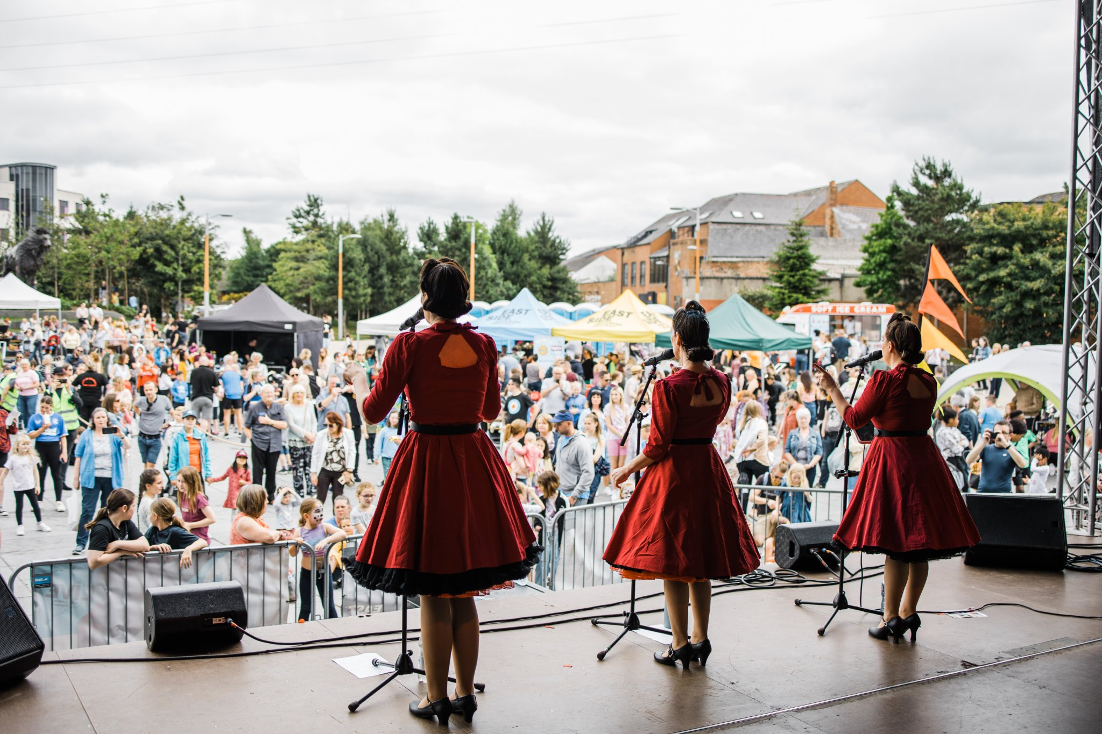

Contents

- Welcome

- Overview of EastSide Partnership

  - Overview, Vision and Mission
  - Aims
  - Values

- Overview of EastSide Arts

  - Aim and Objectives

- The Role of the EastSide Arts Board

  - Context
  - Charity Commission Trustee Duties
  - Trustee Role and Responsibilities
  - Expectations of Individual Trustees

- Commitment Required

- What We Can Offer You

- Board Recruitment Process

  - Person Specification
  - Process/ How To Apply

- Welcome

Thanks for your interest in EastSide Arts and I hope you will give thought to joining the Board. Our plans are ambitious as we begin to focus on making sure that everyone in East Belfast has access to culture and creativity every day of the year. We want to help our artists make more work and our audiences to see themselves reflected in our stories. And to do that, we want to hear from new voices. Previous board or committee experience is not necessary; all we ask is that you have a passion for this place and its people.

You will see in the pack that we are looking for some specific experience around placemaking, financial management and income generation. As part of EastSide Partnership, our focus in the coming years is the regeneration of east Belfast through culture in its widest sense, so we would love to hear from anyone who has experience in this area.

Fiona Bell
Chair, EastSide Arts

- Overview of EastSide Partnership

2.1 Overview, Vision and Mission EastSide Partnership

EastSide Partnership is a broad-based regeneration charity working across physical regeneration, education, poverty alleviation, arts, tourism and heritage. Formed in 1995 (founded in 1996), EastSide Partnership has led high impact, strategic regeneration initiatives across east Belfast for the last 25 years.

With a governance structure made up of committed representatives from the community, statutory, political and business (independent) sectors, EastSide Partnership's organisational mission is simple, ’to make east Belfast a better place’. Such is the nature of EastSide Partnership's regeneration work, our mission is deliberately broad as is the context within which we operate.

Our core role is to facilitate and initiate development, co-ordinate and connect stakeholders and partners, encourage others to develop and provide services locally and advocate for influence and future investment for east Belfast.

Our vision is that east Belfast will be a vibrant, thriving community where people want to live, work, invest and visit.

It will be a confident community where people from all backgrounds and areas feel they have a stake, where people are employable and have access to jobs and opportunities, residents enjoy good health and wellbeing, and education is valued with educational standards raised in all areas.

It will be a warm and welcoming community, where tourism, hospitality and the arts are thriving.

2.2 Aims

EastSide Partnership aims to:

- Create an east Belfast that is a thriving cultural hub, where the arts are valued, creativity is for everyone and people are connected with each other and the wider world through EastSide Arts
- Promote the use and development of green open spaces, parks, rivers and off-road transport routes in east Belfast through EastSide Greenways including Connswater Community Greenway
- Help and support children in east Belfast to develop their abilities, reach their potential and experience success, whatever their background through EastSide Learning
- Contribute to the regeneration of east Belfast through the strategic acquisition, development and management of sites and properties through EastSide Property
- Coordinate and deliver responsible, sustainable and impactful culture-led regeneration, pushing boundaries to put east Belfast on the map through EastSide Tourism
- Raise awareness and help alleviate the impact of poverty in inner east Belfast through the Scaffolding Project

2.3 Values

Alongside the principles adopted from the NI Charity Commission Code of Good Governance and the Nolan principles- Selflessness, Integrity, Objectivity, Accountability, Openness, Honesty and Leadership, there are a number of other principles which EastSide Partnership and its subsidiary companies value highly and which we seek to apply through all of our work:

1. Alleviating poverty and disadvantage – we seek to ensure that we alleviate poverty and disadvantage through social, economic and environmental regeneration.
2. Entrepreneurship – we seek to take an entrepreneurial approach to developing our organisation and its activity, seeking out opportunities, taking well managed risks and focussing on effective outcomes.
3. Economic Sustainability – we are committed to being as financially sustainable as possible through an entrepreneurial approach whilst aiming to reduce dependence on grant aid and having resources to test ideas which may not initially attract public support.
4. Environmental Responsibility – we commit ourselves to policies and practices that will reduce the negative impact of our activity and positively promote environmental responsibility.
5. Respect for heritage – we respect the rich heritage of east Belfast and its contribution to making the community and the wider world a more inspirational place to live.
6. Inclusivity - we promote a welcoming ethos, are respectful of difference and seek to reflect the diverse demographic and culture of contemporary east Belfast in all our projects and structures.
7. Collaborative working – we are committed to working collaboratively, both within our own organisation and with other external stakeholders, in order to achieve our desired outcomes.

- Overview of EastSide Arts

3.1 Aim & Objectives

Our vision, mission and values are aligned to that of the parent company, EastSide Partnership. EastSide Arts has the specific project aim of ‘creating an east Belfast that is a thriving cultural hub; where the arts are valued, creativity is for everyone and people are connected with each other and the wider world.’
Objectives for 2021-2023:
- To improve equity of opportunity for people in east Belfast to engage with creative activities
- To create a variety of meaningful, open and inclusive opportunities for people in east Belfast to explore creativity and connect with others
- To celebrate the past, present and future of east Belfast;
- To develop relationships that ensure the long-term stability of EastSide Arts and create investment in the arts in east Belfast

- The role of the EastSide Arts Board

4.1 Context

EastSide Arts is a Company Limited by Guarantee and is a Charity recognised by the Charity Commission for NI and HM Revenue and Customs. It is a not-for-profit organisation and one of 7 wholly owned subsidiaries of EastSide Partnership. EastSide Arts was constituted in January 2015 and registered as a charity with the Charities Commission NI in 2021.

EastSide Arts is governed by a voluntary Board of Directors. The company is managed on a day-to-day basis by a Manager, who is appointed by the Board of Directors. The Manager, with the assistance of two full-time members of staff, manages the day-to-day activities of the company. The Manager reports to the Chairperson and the Board and is line-managed by the Chief Executive of EastSide Partnership, the parent company. EastSide Arts receives core funding from Arts Council Northern Ireland and Belfast City Council. Additional income is raised through applications to statutory funders, Trusts & Foundations and through ticket sales and sponsorship.

The Board is responsible for ensuring that the strategic direction of EastSide Arts is
consistent with its charitable aims and the wider regeneration aims of EastSide Partnership, and is pursued energetically, innovatively and effectively.

4.2 Charity Commission Trustee Duties

The Charity Commission has outlined 6 main duties for “the Essential Trustee”.
- Ensure your charity is carrying out its purposes for the public benefit
  - Knowing what your charity can and can’t do within its purposes
  - Knowing how your charity is fulfilling its purposes and benefiting the public
  - Awareness of what difference your charity is really making

- Comply with your charity’s governing document and the law
- Being familiar with your governing document
- Being up to date with filing accounts, returns and any changes to your charity’s registration details
- Having awareness of other laws that apply to your charity

- Act in your charity’s best interests
- Making balanced, informed decisions
- Recognising & dealing with conflicts of interest
- Ensuring trustee benefits are allowed
- Being prepared to question and challenge
- Accepting majority decisions

- Ensure your charity is accountable
- Managing risks, protecting assets (reputation) and people
- Getting the resources your charity needs
- Having and following appropriate controls and procedures
- Dealing with land and buildings
- Responsibility for, and to, staff and volunteers

- Manage your charity’s resources responsibly
- Using your skills and experience
- Deciding when you need advice
- Preparing for meetings
- Getting the information you need (financial, management)
- Being prepared in case something does go wrong

- Act with reasonable care and skill
- Meeting legal accounting and reporting requirements
- Being able to show that your charity complies with the law and is effective
- Being accountable to members and others with an interest in the charity
- Ensuring that staff and volunteers are accountable to the board
- Welcoming accountability as an opportunity not a burden

4.3 Trustee Role and Responsibilities

The role and responsibilities of the EastSide Arts Board are;

- To determine the organisation’s mission and strategic direction and ensure that the organisation stays within its remit and within the law, and to ensure that the strategic and operational plans that direct the work of the organisation are approved.
- To involve and take into account the views of all stakeholders of the organisation when arriving at board decisions.
- To ensure effective business planning takes place, and to monitor performance against these.
- To develop and approve clearly defined financial management, control and expenditure policies and procedures for the purposes of ensuring transparent and authorised utilisation of resources.
- To approve financial plans and commitment and ensure regular and timely financial reporting against budget occurs.
- To approve and ensure effective corporate governance arrangements for the organisation are in place, and that these are fit for purpose.
- To ensure that board members have the appropriate suite of skills to comprehend and utilise financial and governance information they are asked to review. To this end, the board should enable this through appropriate and effective induction processes.
- To review and assess the effectiveness and impact of governance arrangements in the organisation on an ongoing basis.
- To ensure that the organisation meets all of its statutory and legal requirements with regard to complying with company law obligations, and that it at all times acts in accordance with the relevant governing documents.
- To ensure that the organisation meets all of its statutory and legal requirements with regard to employment practices, equality obligations and that staff are supported in fulfilling their roles by means of effective staff development processes.
- To ensure that an effective audit by a professionally recognised auditor takes place, approve the annual accounts, and take on board the resulting recommendations of the management letter from the external auditors.
- To select and ensure good management of the Manager.
- To ensure that adequate funding is in place, and that productive relationships are maintained with representatives of funding organisations, and that the organisation is represented in these settings through effective engagement with key stakeholders.

4.4 Expectations of Individual Trustees

Each Board Member has the following responsibilities, and is accountable to the Board for them;

- To read the board papers in advance of the meeting
- To attend and contribute to Board, committee and working group meetings, and be punctual or, where attendance is not possible, to submit apologies for non-attendance in advance.
- To prepare for and contribute to Board and working group meetings by suggesting issues for discussion in the agenda and adhering to the agenda at meetings.
- To maintain respect for the confidential nature of issues designated as such by the Chair at meetings.
- To question appropriately but to share collective responsibility for decisions.
- To be well informed about the organisation’s purpose, services and strategies, and its operating environment.
- To challenge and support the Manager.
- To undertake other functions as required (e.g.) selection panels, working groups.
- To represent the organisation and speak on its behalf when asked to do so.
- To ensure balance is maintained between strategic and operational management.
- To develop and maintain good relationships with key stakeholders of the organisation, in particular the staff and those who the Partnership serves.
- To act with due care and diligence in discharging all legal, regulatory and organisational duties required of a board member.
- To avoid even the appearance of a conflict of interest, and to disclose any possible conflicts to the Chair immediately.
- To uphold and promote the values of EastSide Arts and EastSide Partnership.

- Commitment Required

Why become a Trustee?

EastSide Arts is an exciting and innovative culture-led regeneration charity focused on ‘making east Belfast a better place’ as part of the wider EastSide Partnership. We have an ambitious and creative year-round programme that includes the EastSide Choir, Big Kids’ Society social events, Artful Ageing and HOME projects, the annual EastSide Arts Festival and contributions to Partnership-wide events including the C.S. Lewis Festival and July Weekender. We also work with community partners to deliver reactive projects based on need. We have recently been awarded 4-year funding from the Paul Hamlyn Foundation to deliver the Creative Citizens programme which aims to address gaps in creative provision across east Belfast.

We are seeking a number of passionate and experienced people to support our work as a leading arts organisation in east Belfast. As a new Trustee you will join the existing board and be accountable for supporting the organisation to deliver its strategic plan, developing future strategic goals and leading the continued growth and profile of the organisation.

What We Will Ask From You?

- The Board meets every quarter for approximately 2 hours. Meetings are currently held on a Tuesday evening from 5pm – 7pm at the EastSide Partnership offices. Dates are set for all Board meetings at the beginning of the financial year.
- In addition, there will be one annual strategic planning day in the autumn.
- The Board may set up ad hoc working groups to look at specific areas of work as required, for which you may be asked to volunteer.
- An annual EastSide Partnership strategic planning day (or overnight) takes place annually which you will be invited to attend.
- On occasions you may be invited to attend public events to represent the organisation.

- What We Can offer You

As a Trustee we will offer you ongoing professional training and development and the opportunity to make significant regeneration impact in east Belfast. Becoming a Trustee will give you the potential to develop your own leadership and decision-making skills and to grow your professional networks.

- Board Recruitment Process

7.1 Person specification

We are committed to making all of our recruitment as accessible and inclusive as possible. We want to be open and transparent about what we are looking for from applicants and ask you to complete an application form, rather than submit a CV. In order to maintain and develop an effective Board, we regularly review the Board’s membership to ensure there is a good balance of:
- Skills, knowledge and experience
- Perspectives and connections
- Diversity

We balance the need for continuity and renewal by having a maximum tenure of 3 terms for Board members, with a review after each term. Each Trustee will undergo an annual appraisal with the Chair to ensure both the company and Trustee are benefitting from the relationship. When reviewing the skills that are needed by the Board, we will refer to our Strategic Plan, and decide what key challenges will face the Board in the foreseeable future. We also consider the kinds of people who are likely to make a valuable contribution to our work as a Board.

Based on our most recent analysis of the skills and expertise of the Board, we are keen to recruit candidates that can demonstrate a passion for and commitment to cultural engagement in east Belfast and at least one of the following skills –

- Expertise in commercial income generation and fundraising strategies
- Knowledge and experience of place-based regeneration practices
- Financial management and business planning experience

In addition to experience, we also look for candidates with specific personal attributes which are:

- The ability to challenge respectfully and at the right level.
- The ability to participate beyond your own experience.
- The ability to work effectively as a team member and for the good of EastSide Arts.
- The ability to think creatively.

7.2 Process/ How To Apply

The following is our process for recruitment of a new Board member:
- Applications to be emailed to gillian@eastsidepartnership.com by 12pm on Wednesday 1st March 2023.
- Shortlisting will be carried out by the Chair and at least one Trustee on Monday 6th March 2023.
- Interviews will take place in person at Avalon House, 278-280 Newtownards Road on Monday 13th March 2023.
- The Chair will make a recommendation of suitable candidates to the EastSide Partnership Nominations Committee.
- When candidates are approved by the Nominations Committee, they will be invited to attend one meeting as an observer before making the commitment to join the Board.
- Newly appointed Trustees will be co-opted onto the EastSide Arts Board at the EastSide Partnership AGM in December 2023.

For further information about EastSide Arts, our strategy and projects, please visit our website - www.eastsidearts.net

A recent example of the sort of work that we are passionate about can be found here

For further information about the role of Trustee, please contact -

Rachel Kennedy, Manager
rachel@eastsidepartnership.com
07817 532922
Avalon House
278-280 Newtownards Road
Belfast, BT4 1HE

Facebook: https://www.facebook.com/EastSideArtsBel/
Twitter: https://twitter.com/EastSideArtsBel
Instagram: https://www.instagram.com/eastsideartsbel/

